6th Feb

Corner less than 11-100--------------Won 140

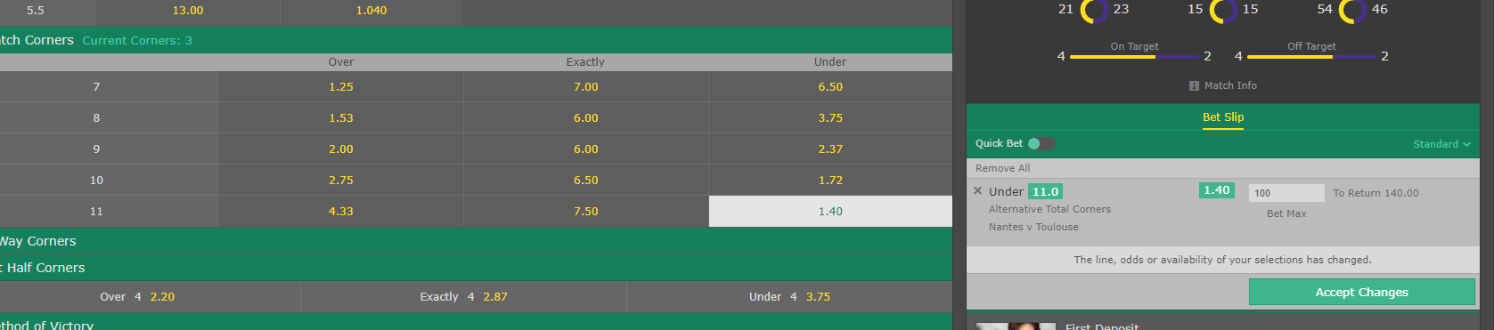

Corner less than 11 -61.5----Won 88

